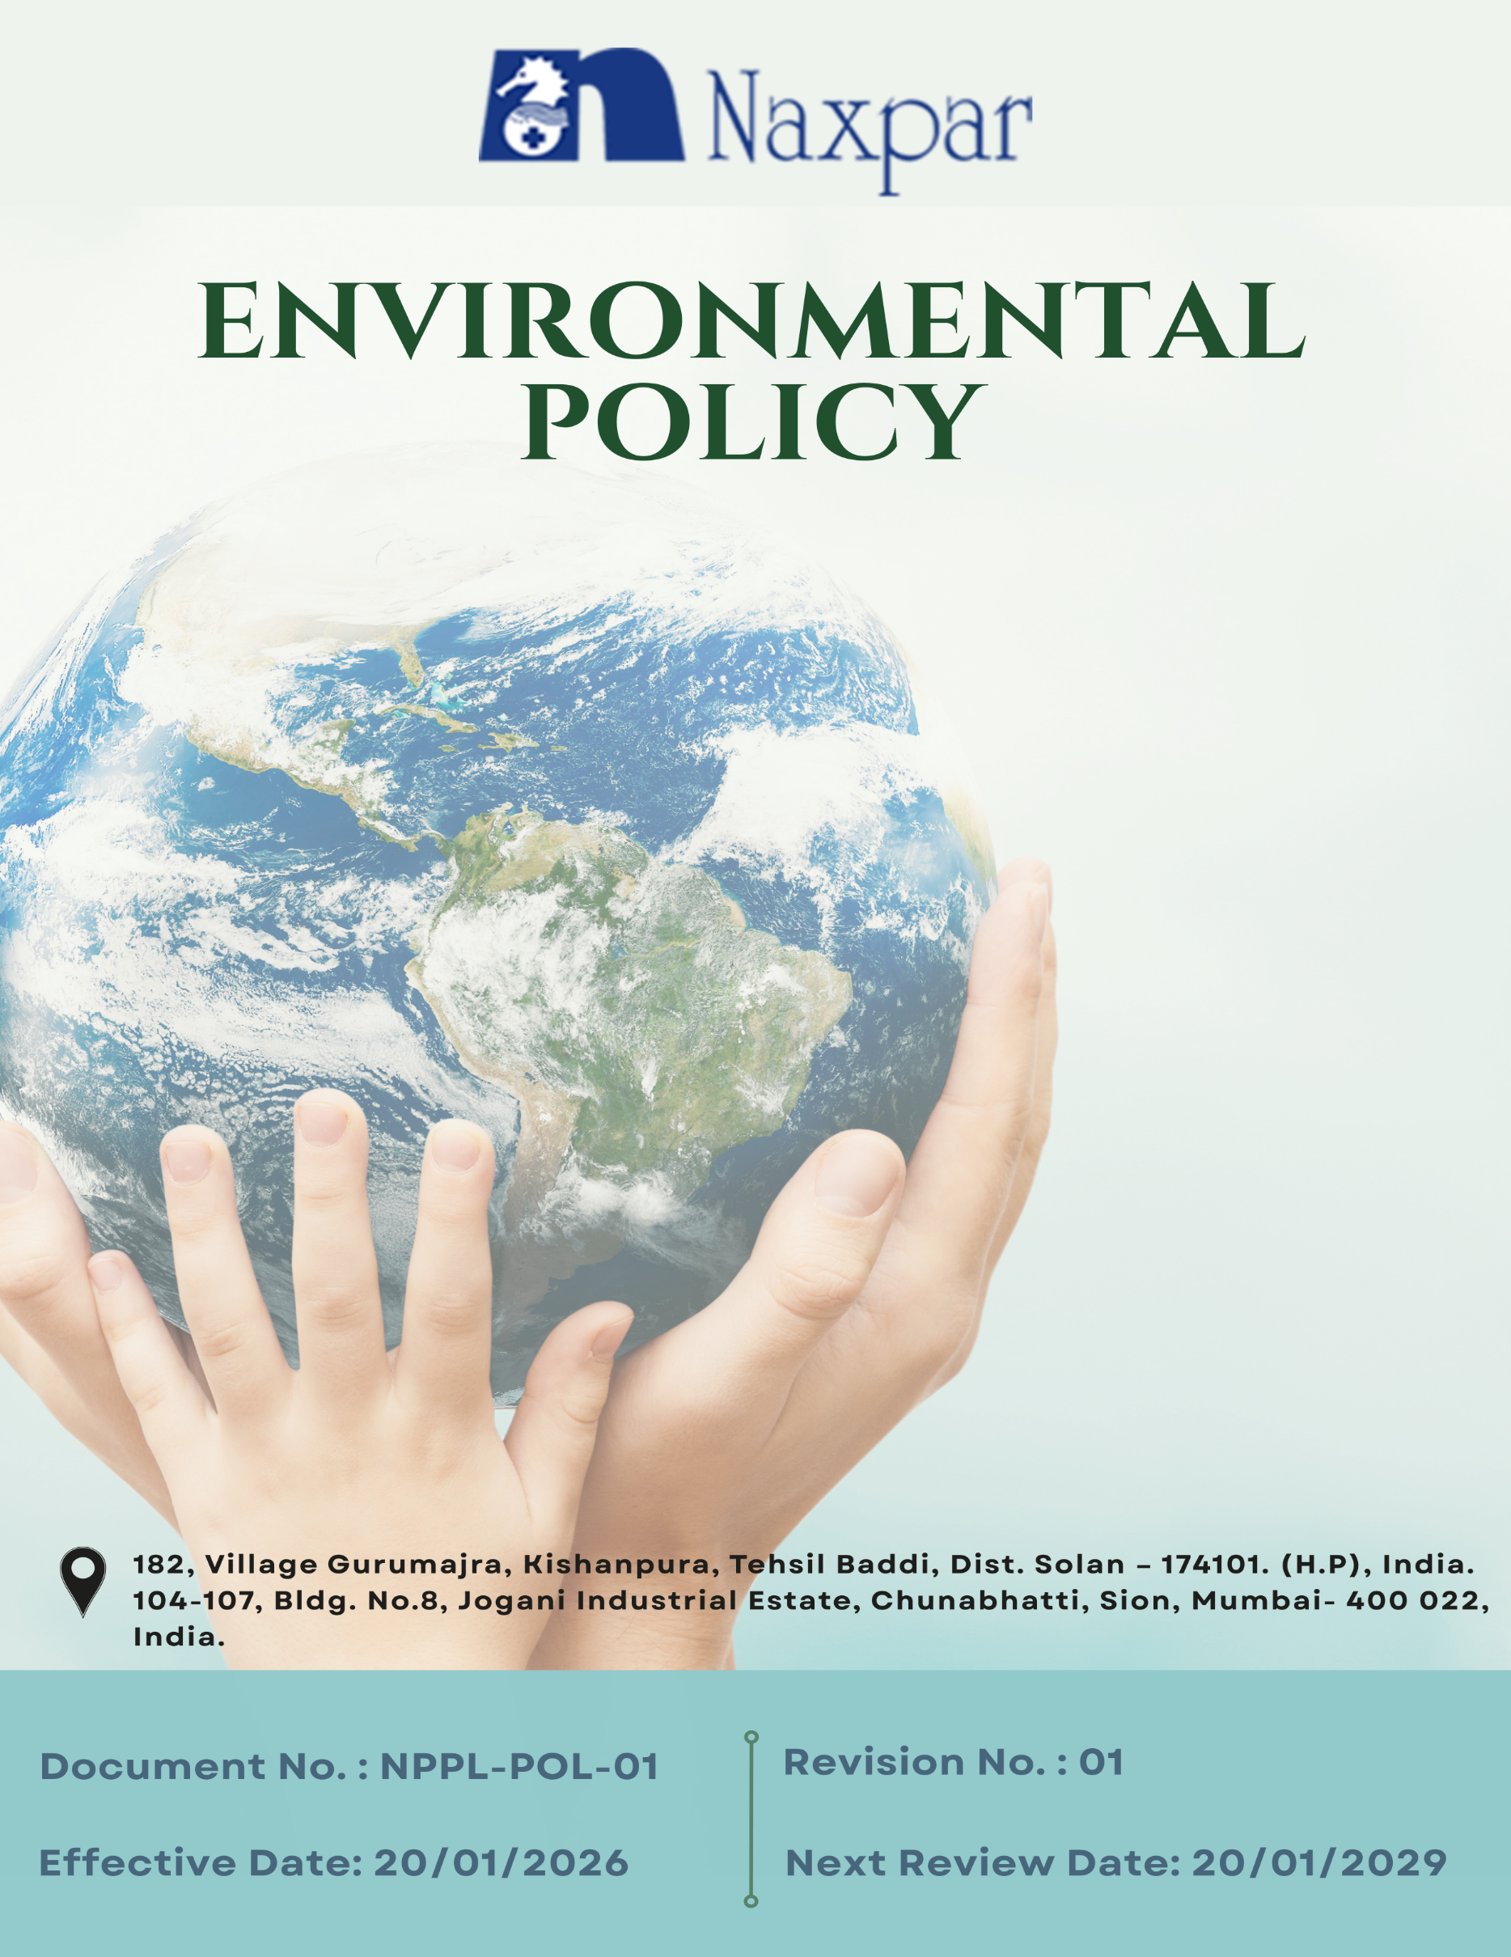

Contents

Preface 2
Policy Declaration 3
Scope 3
Key Focus Areas 4
Qualitative Objectives 5
Quantitative Targets 8
Alignment with the United Nations Sustainable Development Goals (SDGs) 10
Responsibilities 11
Monitoring, Reporting, and Transparency 11
Review Mechanism and Continuous Improvement 12
Employee Acknowledgment Form 13

Preface
Naxpar Pharma Pvt. Ltd. is committed to to minimizing its environmental impact and promoting sustainable development through responsible environmental management and continual improvement. As a manufacturer and developer of finished formulations in pharmaceuticals, cosmetics, herbal/ayurvedic products, and nutraceuticals, the Company recognizes that its activities interact with the environment and therefore strives to prevent pollution, conserve natural resources, and comply with all applicable environmental laws and regulatory requirements. With modern, state-of-the-art manufacturing facilities, Naxpar integrates advanced technologies and professional practices to support environmentally sound operations.
This Environmental Policy provides the framework for Naxpar Pharma Pvt. Ltd.’s environmental objectives and targets, and defines the approach for managing environmental aspects across its operations. It guides employees, contractors, and stakeholders in incorporating environmental considerations into planning and daily activities, with the goal of improving resource efficiency, reducing emissions and waste, and strengthening overall environmental responsibility as part of the Company’s Integrated Management System

Policy Declaration
Naxpar Pharma Pvt. Ltd. is committed to protecting the environment by preventing pollution, complying with applicable environmental laws, and continually improving its environmental performance. The Company ensures responsible use of natural resources, efficient energy and water consumption, control of emissions and effluents, and safe waste management, while integrating environmental considerations and risk management into its business decisions. Through awareness, training, and stakeholder engagement, Naxpar Pharma Pvt. Ltd. promotes sustainable practices across its operations, and this policy is endorsed by senior leadership and regularly reviewed to ensure its effectiveness.

Scope
This Environmental Policy applies to all operations of Naxpar Pharma Pvt. Ltd., including pharmaceutical formulation, cosmetic, herbal/ayurvedic, and nutraceutical manufacturing, as well as all supporting and ancillary activities related to production. It is applicable at all levels of the organization and across all business functions, and is supported by systematic monitoring, evaluation, and corrective actions to ensure the achievement of environmental objectives and targets.

Sr. No. | Company Name | Location | Address Details
1 | Naxpar Pharma Pvt. Ltd. | Head office | 104-107, Bldg. No.8, Jogani Industrial Estate, Chunabhatti, Sion, Mumbai- 400 022, India.
2 |  | Plant | 182, Village Gurumajra, Kishanpura, Tehsil Baddi, Dist. Solan – 174101. (H.P), India.

Key Focus Areas
- Energy Consumption & GHG Emissions – Optimize energy use across facilities to reduce greenhouse gas emissions and improve energy efficiency.
- Air Emissions Control – Implement controls and monitoring to minimize air emissions from manufacturing and support operations.
- Raw Materials Management – Promote responsible sourcing and efficient use of raw materials in pharmaceutical, cosmetic, herbal, and nutraceutical production.
- Waste Management – Ensure safe segregation, handling, treatment, and disposal of solid, liquid, and hazardous waste generated from operations.
- Water Stewardship – Conserve and manage water resources through efficient use, recycling, and responsible discharge practices.
- Biodiversity Protection – Support practices that minimize impact on surrounding ecosystems and contribute to local environmental conservation.
- Responsible Product Use – Encourage safe and environmentally responsible use of products through quality manufacturing.
- Product End-of-Life Management – Support proper disposal and recycling to reduce the environmental impact of products after use.
- Customer Health & Safety – Ensure customer health and safety through strict quality control and monitoring.
- Employee Awareness & Engagement – Promote environmental awareness through training and active engagement.
- Environmental Services & Advocacy – Collaborate with partners and stakeholders to advance sustainability initiatives across operations.

Qualitative Objectives
- Energy consumption & GHG Emissions
- Enhance energy efficiency by deploying energy-efficient motors, pumps, variable frequency drives (VFDs), and LED lighting across operations.
- Assess and adopt cleaner fuel and energy alternatives where feasible to reduce greenhouse gas emissions.
- Monitor energy consumption through periodic reviews to identify reduction opportunities.
- Encourage responsible energy-use practices through employee awareness initiatives.

- Air Emissions Control
- Ensure effective operation and regular maintenance of scrubbers, filters, and local exhaust ventilation systems to control process emissions.
- Conduct regular stack and ambient air monitoring to ensure compliance with applicable air quality norms.
- Minimize fugitive emissions through appropriate chemical storage, closed handling practices, and routine equipment upkeep.

- Raw Materials Management
- Improve raw material efficiency through batch optimization, yield enhancement, and standardized manufacturing processes.
- Reduce material losses by strengthening inventory controls, storage conditions, and handling practices.
- Promote optimized chemical dosing and evaluate substitution of high-loss materials where technically and regulatorily feasible.
- Track raw material consumption trends to identify improvement opportunities.

- Waste Management
- Ensure effective segregation, treatment, and disposal of hazardous and non-hazardous waste.
- Minimize waste generation through adoption of reduction, recycling, and responsible disposal practices to support a circular economy.
- Ensure safe management of hazardous waste via co-processing and incineration to achieve zero landfill.

- Water Stewardship
- Optimize freshwater consumption through process improvements, leak prevention, and efficient water-use practices.
- Operate and continuously improve water recovery and recycling systems to maximize internal reuse.
- Monitor effluent quality at regular intervals to ensure compliance with discharge standards.
- Track water consumption data to identify conservation opportunities.
- Promote water conservation awareness among employees and contractors.

- Biodiversity Protection
- Minimize operational impact on local ecosystems around manufacturing facilities.
- Develop and maintain green belts with native plant species around manufacturing facilities.
- Collaborate with local communities to support tree plantation, and clean-up initiatives that enhance awareness and conservation.

- Responsible Product Use
- Provide customers with clear instructions on safe handling, storage, and efficient use of products.
- Offer technical support to help customers minimize waste, emissions, and resource consumption during product use.
- Review customer feedback to enhance product performance and environmental compatibility.

- Product End-of-life Management
- Facilitate safe disposal or recovery of expired or off-specification products through authorized facilities.
- Encourage reuse or recycling of containers, drums, and packaging materials wherever feasible.
- Engage customers and distributors on appropriate end-of-life disposal practices.
- Periodically review end-of-life management processes to identify improvement opportunities.

- Customer Health and Safety
- Maintain high standards of product quality and safety monitoring.
- Respond promptly to adverse event reporting and product complaints.
- Promote customer awareness of safe handling and usage through training and guidance programs.

- Employee Awareness & Engagement
- Conduct regular training programs to build environmental awareness.
- Integrate environmental responsibilities into SOPs and daily operations to promote sustainable practices.
- Encourage proactive participation in sustainability initiatives.

- Environmental Services & Advocacy
- Collaborate with industry partners, regulators, and stakeholders to advance sustainability practices.
- Engage suppliers and contractors on environmental compliance and responsible sourcing practices.

Quantitative Targets
The baseline year for all quantitative environmental targets at Naxpar Pharma Pvt. Ltd. is established as FY 2022–23, serving as the reference point for measuring progress across the Company’s key environmental focus areas. This baseline enables a structured and consistent evaluation of improvements in resource efficiency, emissions reduction, and overall environmental performance.

- Energy consumption & GHG Emissions
- Achieve 100% LED lighting coverage across all operations by FY 2029–30 and maintain thereafter.
- Achieve 5% reduction in energy consumption by FY 2029-30.
- Reduce Scope 1 and Scope 2 GHG emissions by 5% respectively till FY 2029-30.
- Complete replacement of 100% conventional motors and fans with IE3/EC units till FY 2029-30.

- Air Emissions Control
- Upgrade or retrofit 50% of existing air pollution control systems with improved filtration media, automated monitoring, or efficiency-enhancing components by FY 2029–30 to reduce particulate and gaseous emissions.
- Achieve a 5% reduction in process-related VOC and particulate emissions by FY 2029–30.

- Raw materials Management
- Achieve a 15% reduction in raw material wastage per MT of formulations produced by FY 2029–30.
- Increase usage of environmentally friendly raw materials by 30% by FY 2029-30.

- Waste Management
- Achieve zero landfill for all hazardous waste by FY 2029–30.
- Achieve 100% tracking and reporting coverage for all hazardous and non-hazardous waste streams by FY 2029–30.
- Reduce total waste generation per MT of production by 20% till FY 2029–30.

- Water Stewardship
- Reduce total freshwater consumption by 45% till FY 2029–30 through water-efficient practices.
- Recycle 60% of water from condensate, bottle washing, and DM plant rejects by FY 2029–30.
- Optimize and maintain closed-loop cooling systems to reduce cooling-related freshwater consumption by 25% by FY 2029–30.

- Biodiversity Protection
- Plant and maintain 1000 native trees around company facilities to enhance green cover and biodiversity by FY 2029–30.
- Conduct 2 community tree plantation and clean-up drives till FY 2029-30.
- Maintain 85% survival rate for all plantation and green-belt development activities till FY 2029-30.

- Responsible Product Use
- Achieve a 10% reduction in the lifecycle environmental footprint of key products by FY 2029–30.
- Achieve 90% customer compliance with sustainable and safe product use (via surveys/feedback) by FY 2029-30.

- Product End-of-life Management
- Collect and recycle 10% of sold products/packaging materials through take-back programs by FY 2029-30.
- Ensure provision for 100% safe disposal of expired products through authorized waste management facilities till FY 2029-30.

- Customer Health and Safety
- Conduct 2 customer awareness or training programs on safe product handling and use till FY 2029-30.
- Maintain zero product recalls or regulatory actions related to customer health and safety annually.
- Ensure 100% of products have accurate labeling, hazard communication, and up-to-date SDS till FY 2029-30

- Employee Awareness & Engagement
- Conduct 3 training programs annually for employees on environmental and sustainability topics.
- Achieve 90% active employee participation in sustainability initiatives till FY 2029-30.

- Environmental Services & Advocacy
- Conduct 3 knowledge-sharing workshops or training sessions for suppliers and partners by FY 2029-30.
- Train 85% of suppliers on sustainability practices and environmental management by FY 2029–30.

Alignment with the United Nations Sustainable Development Goals (SDGs)
The sustainability objectives and performance targets align with the following Sustainable Development Goals (SDGs):
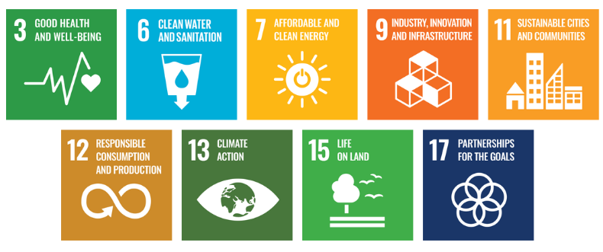

Responsibilities
- EHS Manager: Lead implementation of environmental programs, ensure compliance, and oversee monitoring, reporting, and training.
- Department Heads & Operations Teams: Integrate environmental objectives into operations and implement initiatives on energy, water, emissions, and waste.
- Employees: Follow EHS procedures, use resources responsibly, and support sustainability initiatives.
- Quality & Regulatory Teams: Ensure product compliance with health, safety, and environmental requirements and manage product stewardship.
- External Stakeholders: Comply with environmental standards and support responsible use, disposal, and sustainability efforts.

Monitoring, Reporting, and Transparency
Naxpar Pharma Pvt. Ltd. regularly monitors its environmental performance across key areas such as energy use, greenhouse gas emissions, water management, waste reduction, and product safety. Key Performance Indicators (KPIs) are defined and tracked through internal systems to measure progress against sustainability targets. Performance is reviewed periodically by management to support data-driven decisions and timely corrective actions. Annual evaluations help identify gaps and improvement opportunities, with relevant information shared with stakeholders to maintain transparency and accountability. All monitoring and reporting follow applicable regulations and recognized industry practices to ensure accuracy and reliability.

Review Mechanism and Continuous Improvement
This Environmental Policy will be reviewed once in three years or earlier if required by the EHS Manager and updated as needed to reflect regulatory changes, industry standards, and company priorities. Updates are communicated to employees, contractors, and relevant stakeholders to ensure effective implementation. Revisions focus on strengthening environmental performance, improving resource efficiency, and driving continuous improvement across Company’s operations.

Effective Date | : 20.01.2026
Next Review Date | : 20.01.2029
Revision No. | : 01

Approved By:

Employee Acknowledgment Form
I hereby acknowledge that I have read and understood the Environmental Policy of Naxpar Pharma Pvt. Ltd. I am aware of the company’s commitment to responsible environmental practices, including energy efficiency, resource conservation, waste reduction, pollution control, and full compliance with all applicable environmental laws and standards. I understand that environmental sustainability is a shared responsibility, and I pledge to follow sustainable practices in my daily work, minimizing waste, using resources efficiently, and adhering to the company’s environmental protocols. I will actively support Naxpar Pharma’s efforts to achieve its sustainability objectives and contribute to creating a cleaner, safer, and more responsible workplace.
By signing this document, I confirm my commitment to the environmental values of Naxpar Pharma Pvt. Ltd. and agree to participate in training programs, awareness initiatives, and continuous improvement activities as required.

Employee Name | : _________________________
Employee ID | : _________________________
Department | : _________________________
Signature | : _________________________

